Laboratory occupancy Protocol
Varian Labs Suite 161-5
Prof. G.Gratta, 4 Oct 2020

The lab suite 161-5 in the Varian building is used for experimental studies of gravity. From a technical point of view the labs (161, 163) are configured as clean optics labs, with 153 serving as a gowning room and for electronics and other miscellaneous work. Each of 161 and 163 have 4ftx10ft optics tables roughly centered in the rooms. A schematics of the labs are shown below. Rooms 161 and 163 have HEPA filters in the ceiling providing 2800 cfm each at full speed. Most of the air is recycled, extracted about 1ft above the floor, run through HEPA filters rated to remove 99.99% of 0.3um particles (ENVIRCO model MAC10 LE-DC). Given the volumes of 2300cf for room 161 and 1600cf for room 163, the larger room 161 recirculates >1 volumes/minute with the HEPAs running at full speed.
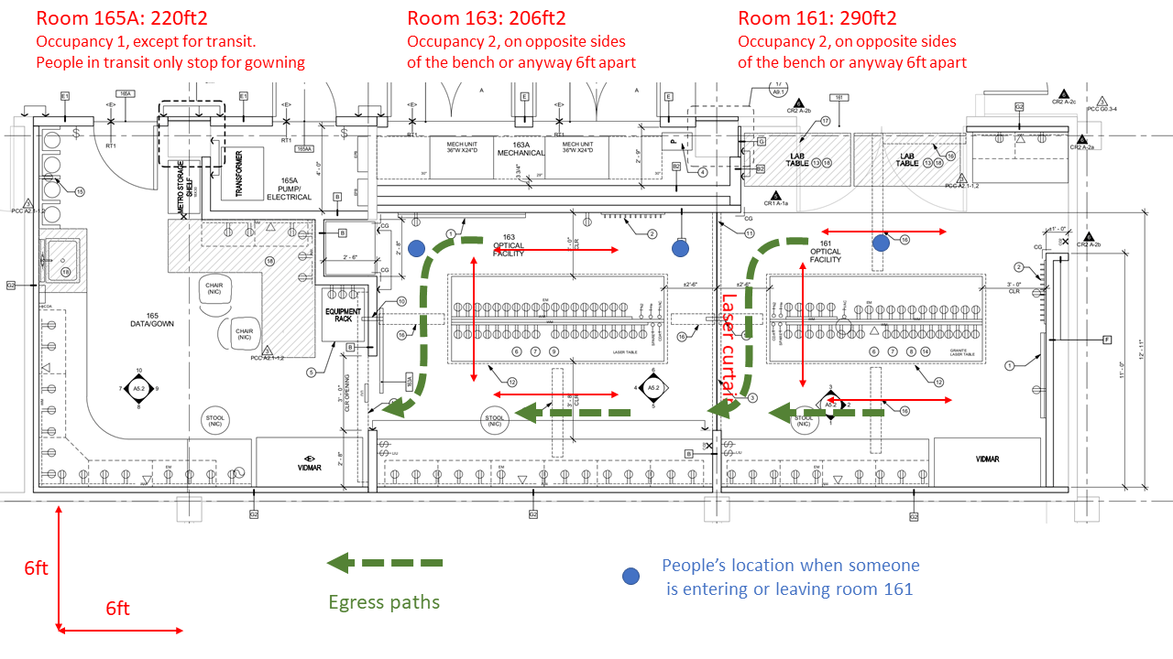
The experiments housed in 161 and 163 are independent. The experiment in 161 sometimes requires two people working in the lab simultaneously. The experiment in room 163 requires less manpower, but only one student, who will graduate soon, knows the apparatus and there is the need to train a new graduate student that is rotating with us.
This document defines the protocols to allow two simultaneous, socially distanced, workers in each of 161 and 163. Since the work in these labs is not at fixed positions, it is not practical to mark places on the floor. Rather, the figure above provides 6ft distance lines, in comparison with the most conspicuous structures, the optical benches. To ensure proper distancing, the two workers in a room will always be on opposite sides of a bench or, if they need to be on the same side, they will work at the opposite ends of the bench. While the first rule does not automatically ensure 6ft distance, the benches are 4ft wide and, even without specifically paying attention, it is physically difficult for two people to be closer than 5ft. In addition, filtered air is provided from the ceiling, including over the optics benches. The circulation, designed for a clean room, moves filtered air from above people’s heads, down to the floor level and then extracted. While much of the air is recycled, HEPA filtering (see above) is of the highest grade available.
Only one person at the time is allowed to work in room 165. However, 165 is also used to enter the lab suite and to gown up. A second person will be allowed only in transit and with proper distancing. It is expected that the transit time, including gowning, will be <2min per occurrence.
Egress shall proceed following the green arrows and signaling other workers (particularly the ones in room 163) when someone is leaving. When someone is leaving 161, people in 161 and 163 will take position at the places marked with the blue circles in the figure. The process is reverse for entering the room. A bell, provided at the entrance of 165 from the hallway, should be used to signal someone’s intension to enter the lab suite.
Of course, all other COVID-19 precautions will apply, including and especially wearing face covering that is not just a scarf or bandana. Proper multi-layer cloth or surgical masks must be worn at all times.

